CHM KEYPUNCH INTERFACE VERSION 2

# Overview

These instructions and the design are valid for 029 Keypunch model A22 using the wire relay logic1. Other models of the 029 and 026 should work but the validation of those connections will be done later.

A small set of modifications to the wiring of the keypunch must be done if you will use the functions to read cards and/or validate correct punching of cards. These involve swapping wires on two relays.

Connections are added from the new interface control box to the logic gate of the keypunch, all connected to the back of the sockets where the connectors (PCBs terminating wires) hook cables from the rest of the machine into the logic gate.

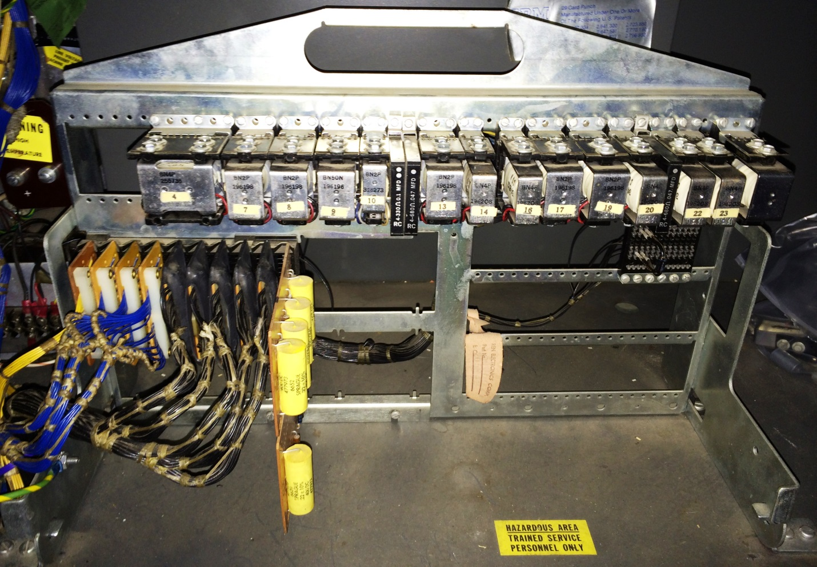

The interface control box is mounted inside the keypunch and a single DB9 socket is installed through the sheet metal frame of the machine at whatever point the builder chooses. This socket provides the RS-232 serial connection to the outside world.

The protocol over the serial link is designed for ease of diagnosis by humans and to support the widest variety of terminal programs or other hardware to link to this interface. Its default mode is ASCII.

# Modifying the keypunch

In order to make use of the read station of the keypunch, which is normally involved to duplicate the holes from the card in this station onto the card to its right in the punch station, we have to allow isolation of the contacts since our interface operates with 5V TTL voltage levels but the keypunch while duplicating passes 48V through the same contacts.

Relay 4, the leftmost relay on the logic gate when looking in from the rear of the keypunch, is called the DUP3 relay. To its right is relay 7, also called the DUP1 relay. These are the two relays whose connections we will modify. To make the change, we swing the logic gate outward and down so it sits parallel to the floor with the back of the gate now accessible.

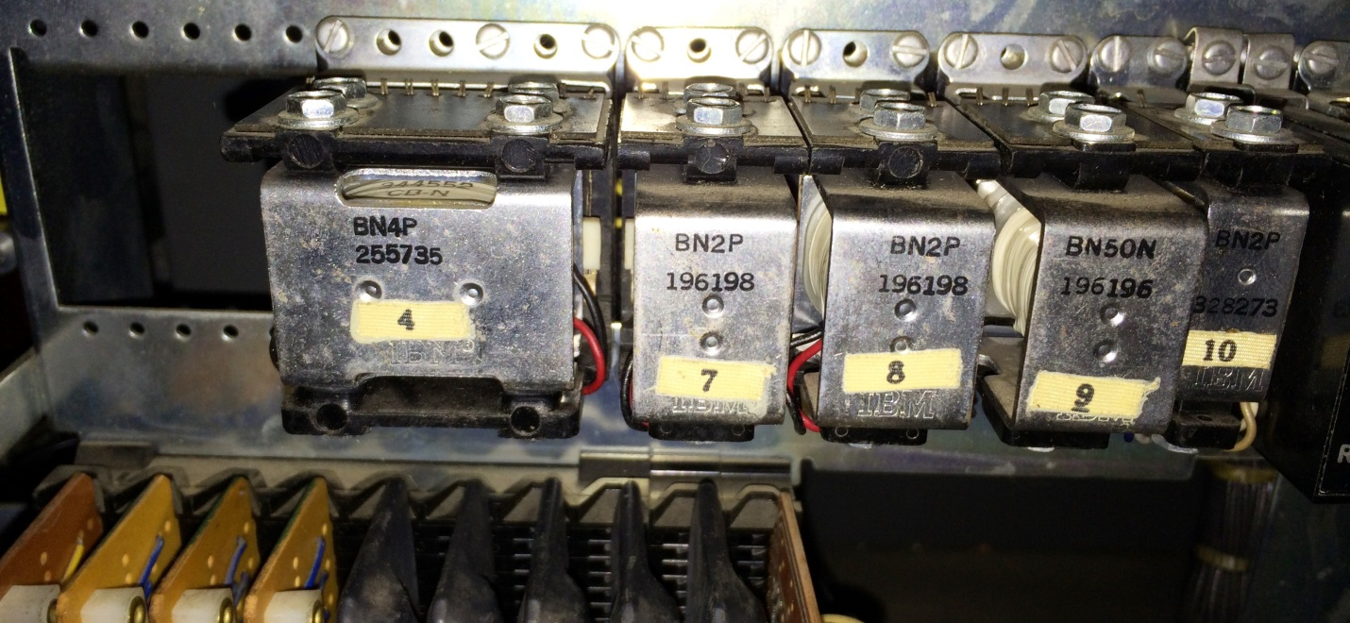

The relay sockets have push pin connectors where various wires are installed. Certain pins will be pulled out of the original hole and pushed into a new hole, moving the wire to that new location. The relay sockets have a standard layout, as viewed by a person looking from behind the keypunch and downward onto the back of the logic gate.

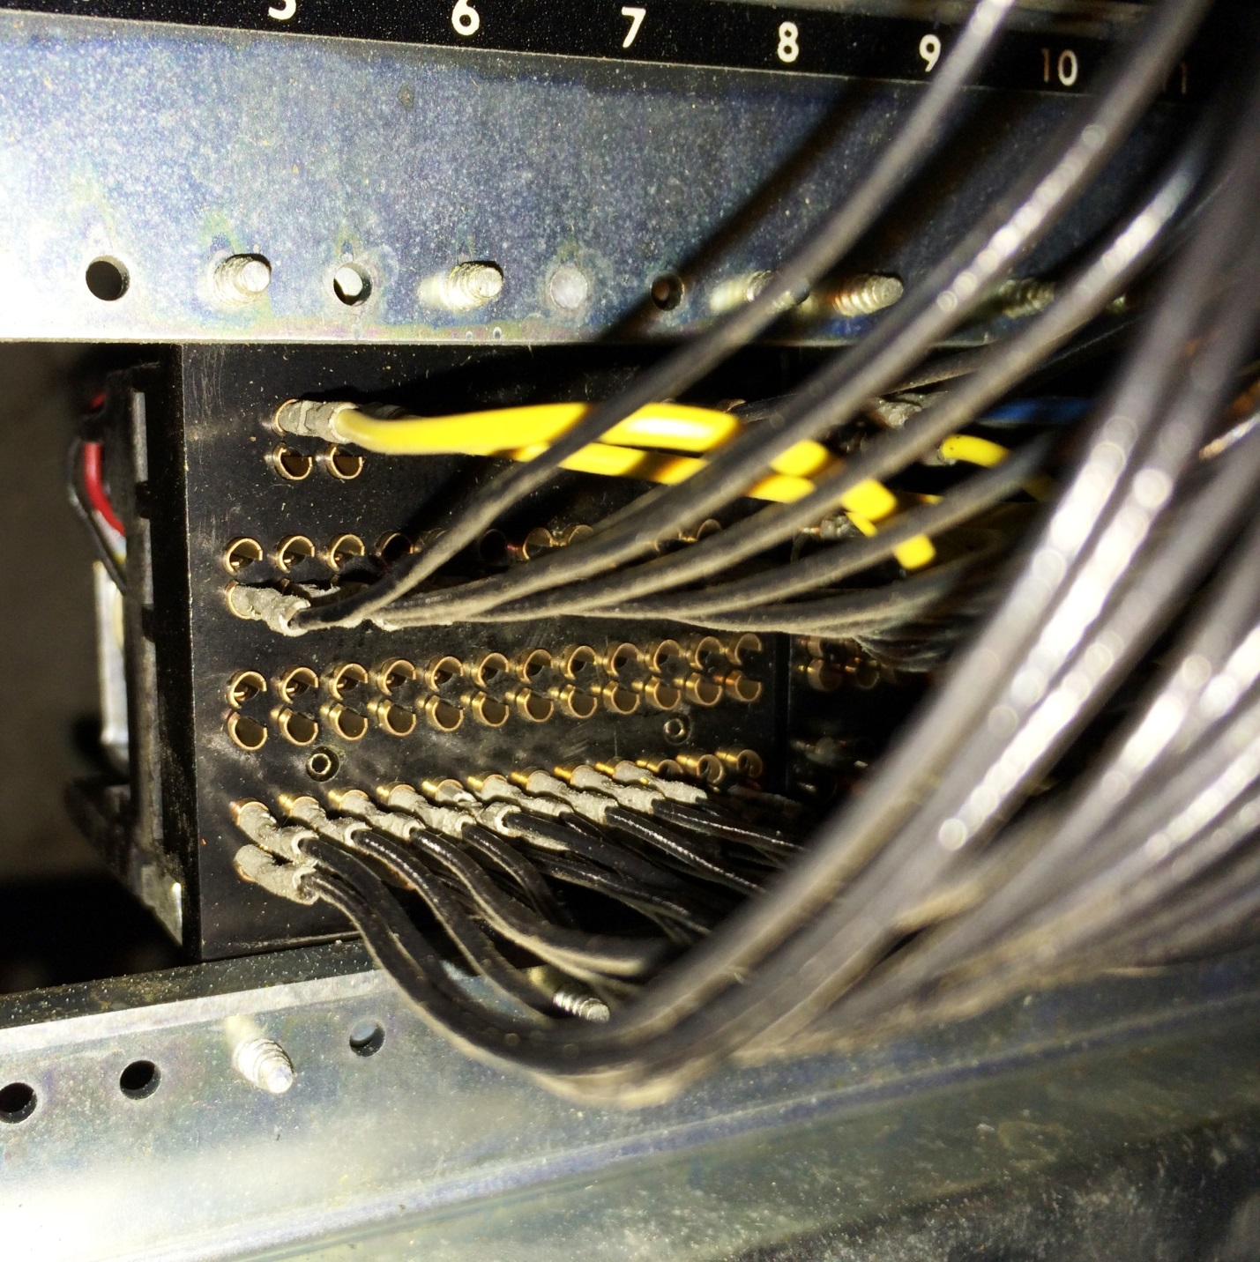

All the connections on the relay socket consist of a pair of holes. At the top are two pairs (four holes) that connect to the coils which energize and hold the relay activated. The next row are the normally open contacts, those that are connected to the pole only when the relay is energized. Continuing down we find the normally close contacts, which are connected only while the relay is not activated. Finally, across the bottom, are the pole contacts which are connected to either N/O or N/C depending on whether the relay is energized.

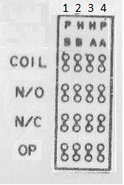

Relay as seen from socket side

We start with the DUP1 relay (number 7) which has six sets of contacts numbered 1 to 6 from left to right. We will change the wires connected to the number 5 set only. We take off the wire from the pole contact of set 5, connected it to the N/O contact of set 5. The wire that was originally connected to N/O of set 5 is moved to the pole contact set 5.

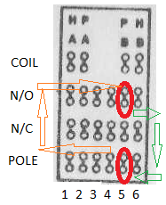

Swap wires for contact set 5

Next, we swap the N/O and POLE wires on all twelve sets of contacts on the DUP3 relay (number 4).The two modifications put the sensing/reading mechanism of the read station on the POLE contacts of both relays, so that the reading mechanism can be switched between the keypunch use for duplicating and the new interface use for reading.

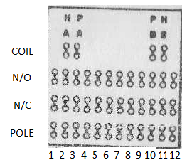

Swap all 12 sets of wires between N/O and POLE

# Wiring of new interface box to keypunch logic gate

The interface box has two DB-25 connectors on it, one male and one female, for connection to the keypunch logic gate. One provides the main punching and control connections (called Punch Cable), the second is added when reading and/or verification of cards is desired (named Read Cable).

The Punch Cable is hooked to positions on the back of the SMS connector panel on the logic gate. Looking at the gate in its normal position, perpendicular to the floor, we see a set of cables, each with a short printed circuit card on the end, that are plugged into the SMS connector panel.

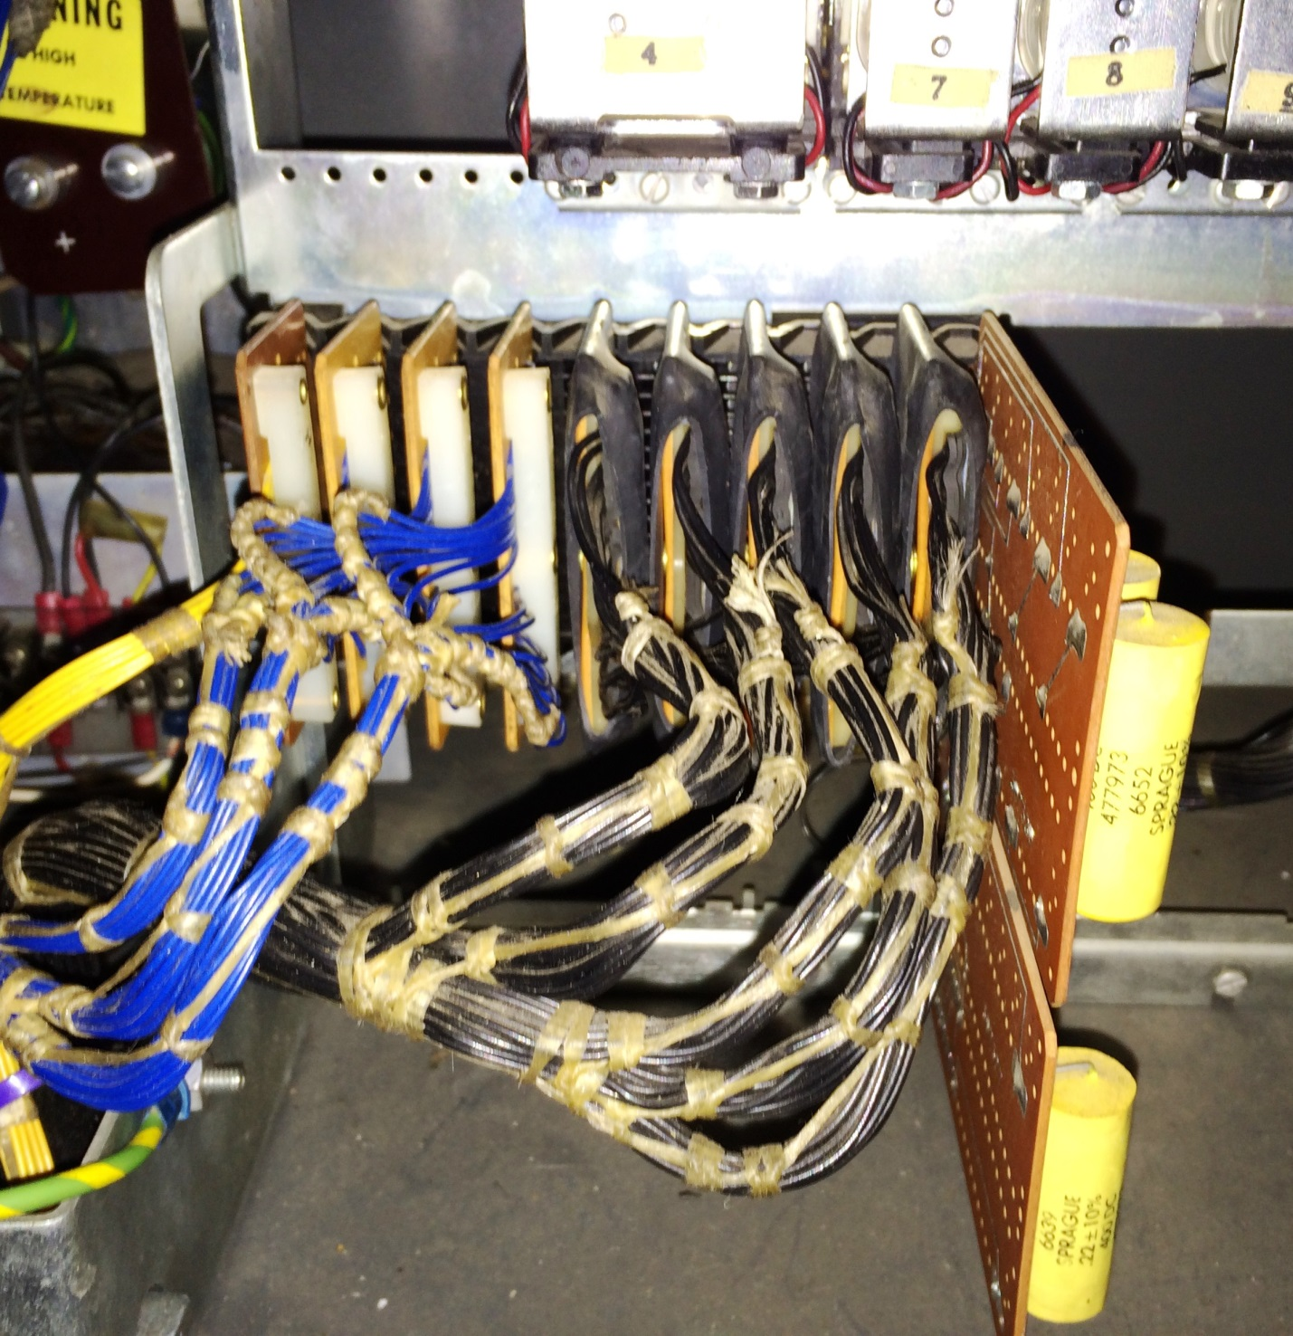

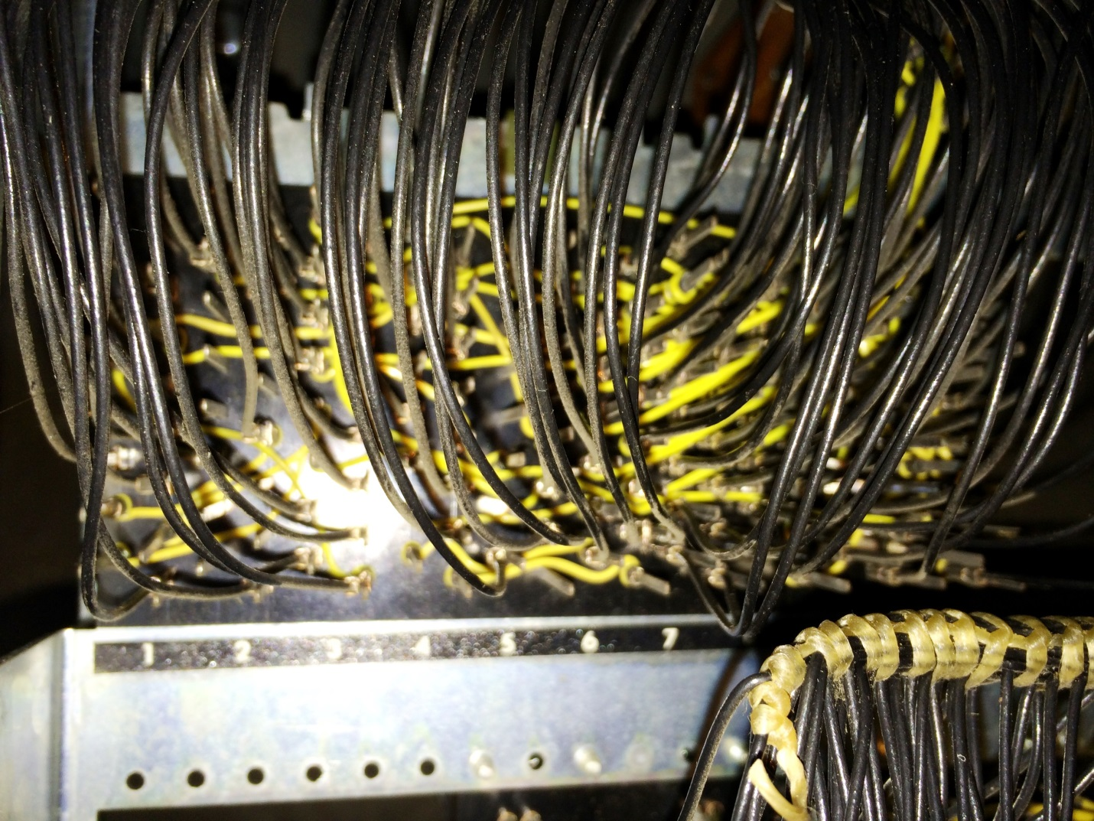

To accomplish the wiring, it is easiest to buy a single DB-25 cable, at least six foot length, that has a male connector on one end and a female on the other. It is important that this be a straight through cable with all 25 connections on each connector. Some cables intended for RS232 serial ports cross wires and use only the contacts relevant to mainstream serial links.

Cut the cable so that you have a three foot section of cable with a connector on each end. The cable with the male connector is the Punch Cable, the other one will be the Read Cable. Wiring the second cable is only needed if f you want the added functionality of reading cards or verifying that prior card punched at the same time as the current card is punched.

### Wiring the Punch Cable

This cable uses 24 wires out of the 25 in the cable, with specific pins on the connector assigned to certain signals. These wires are connected to the logic gate of the keypunch, hooked to either the SMS panel or the relay sockets. After they are connected, the cable should be neatly dressed with cable ties or lacing cord to avoid them snagging on other objects in the future as the gate is opened and closed.

The 12 rows and the space wires are connected to the A06 slot on the SMS panel:

* 12 punch to A06 B and is pin 12 of the Punch Cable
* 11 punch to A06 C and is pin 11 of the Punch Cable
* 0 punch to A06 D and is pin 10 of the Punch Cable
* 1 punch to A06 E and is pin 9 of the Punch Cable
* 2 punch to A06 F and is pin 8 of the Punch Cable
* 3 punch to A06 G and is pin 7 of the Punch Cable
* 4 punch to A06 H and is pin 6 of the Punch Cable
* 5 punch to A06 J and is pin 5 of the Punch Cable
* 6 punch to A06 K and is pin 4 of the Punch Cable
* 7 punch to A06 L and is pin 3 of the Punch Cable
* 8 punch to A06 M and is pin 2 of the Punch Cable
* 9 punch to A06 N and is pin 1 of the Punch Cable
* Space to A06 A and is pin 13 of the Punch Cable

The common connection for the punches is hooked to A03 B on the SMS panel and is pin 15 of the Punch Cable. This is 48V available only when a card is registered and it is okay to punch

48V constant voltage is sourced by connecting to A08 E on the SMS panel and is pin 20 of the Punch Cable. ** NEW NOT ON STAN’S CABLE **

The release relay in the interface box is pin 14 of the Punch Cable and connects to A02 R SMS contact.

The multi-punch relay 1 lines are hooked to A03 L and A03 M SMS contacts and are pins 18 and 19 of the Punch Cable. The multi-punch relay 2 lines are hooked to A03P and Relay 8 section 3 N/O contact. The lead between A03P and Relay 8-3 N/O is cut to that our two wires are now the circuit link between these two points.   
** NEW NOT ON STAN’S CABLE **

The card registered status circuit is connected to pins 16 and 17 of the Punch Cable and hook to a reed switch that is placed alongside the coil of relay 24 (Card Lever), aligned with the axis of the coil. Secure this with a cable tie around the relay.

Wires 23 and 25 of the punch cable are soldered together to act as a test from the Arduino to verify the cable is connected. ** NEW NOT ON STAN’S CABLE **

See the figures below for the wiring points shown on the 029 Keypunch schematics (wire relay type)

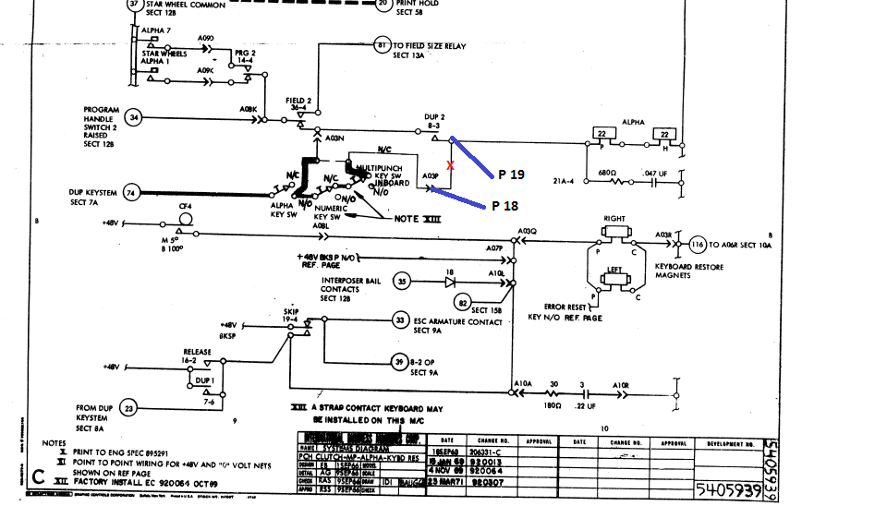

Figure Multipunch modification

Figure Dup relays, swap of wiring

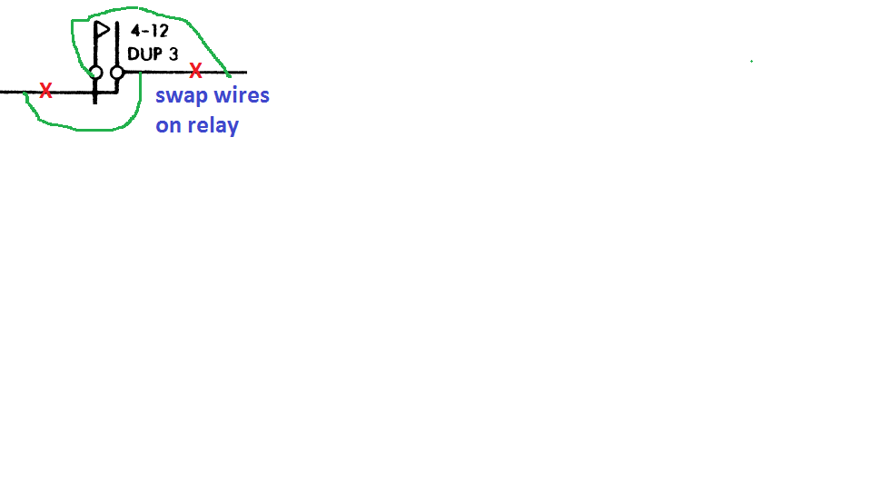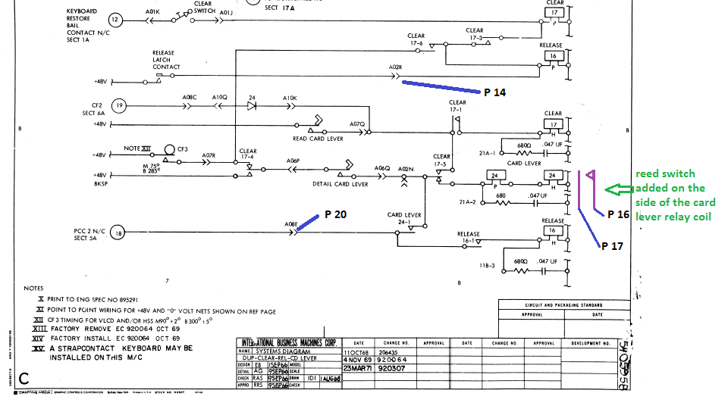

Figure 3 Release, Card Registered and Power

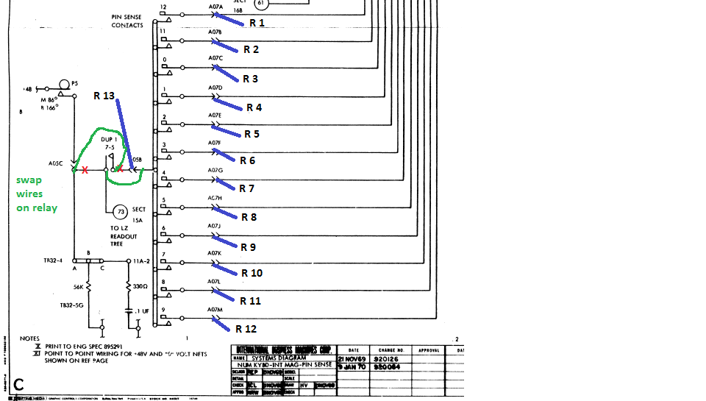

Figure 4 Read pins and DUP relay wire swap

## 

Figure 5 Hole and space wiring, common power

## Wiring the Read Cable

The Read Cable hooks to DUP3 relay N/C contacts at the relay panel:

* Row 12 is wired to contact set 1 and is pin 1 of the cable
* Row 11 is wired to contact set 2 and is pin 2 of the cable
* Row 0 is wired to contact set 3 and is pin 3 of the cableh
* Row 1 is wired to contact set 4 and is pin 4 of the cable
* Row 2 is wired to contact set 5 and is pin 5 of the cable
* Row 3 is wired to contact set 6 and is pin 6 of the cable
* Row 4 is wired to contact set 7 and is pin 7 of the cable
* Row 5 is wired to contact set 8 and is pin 8 of the cable
* Row 6 is wired to contact set 9 and is pin 9 of the cable
* Row 7 is wired to contact set 10 and is pin 10 of the cable
* Row 8 is wired to contact set 11 and is pin 11 of the cable
* Row 9 is wired to contact set 12 and is pin 12 of the cable

Common 5V for the read sensors is on pin 13 of the cable and hooks to DUP1 relay contact set 5 N/C

Connect together the wires from pins 19 and 21, which will be tested by the interface to determine whether the optional reader cable has been installed.

The read cable uses 15 of the 25 wires in the cable.

## Installing new interface box inside the keypunch

Use cable ties to secure the interface box and its cables inside the keypunch but out of the way of the logic gate when it swings open and closed. Two good possibilities are a) the open space on the right of the logic gate, and b) the horizontal tray above the logic gate, which formerly held the reed relay logic before it was superceded by the wire relay logic used on these models.

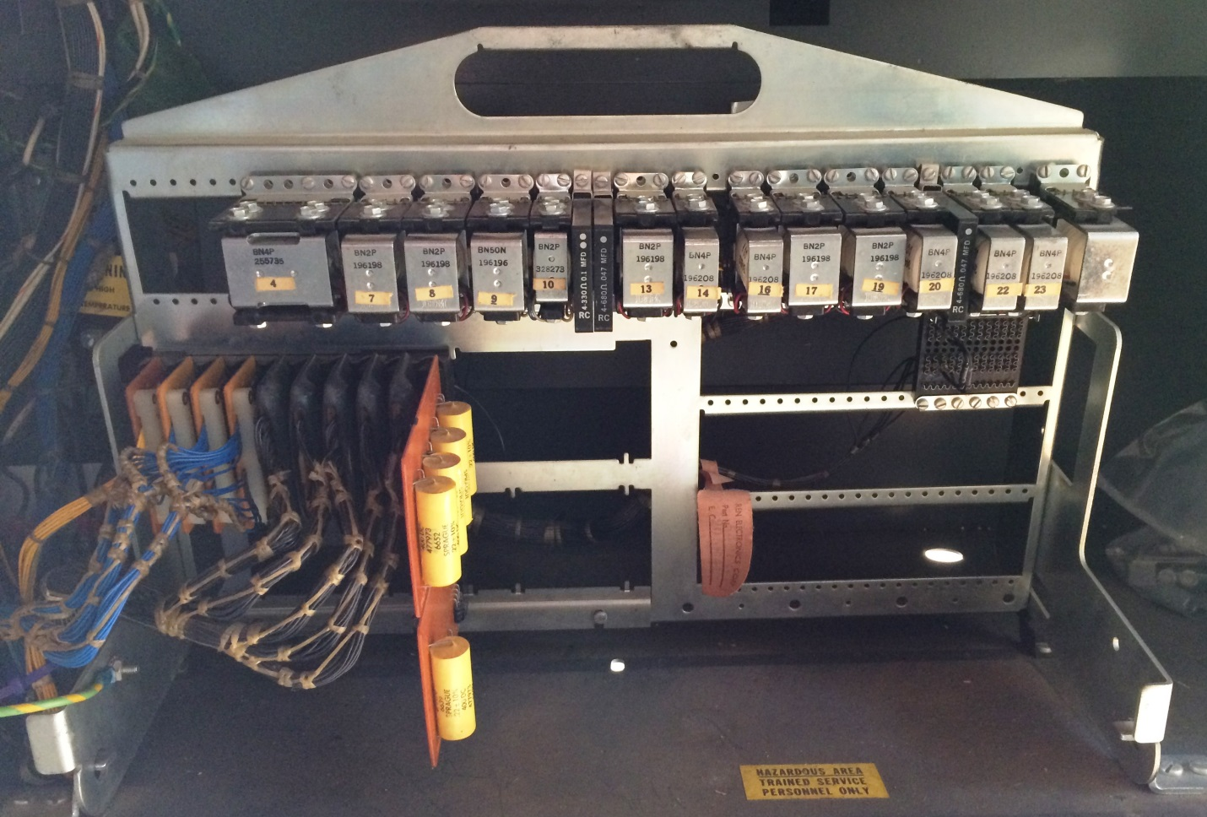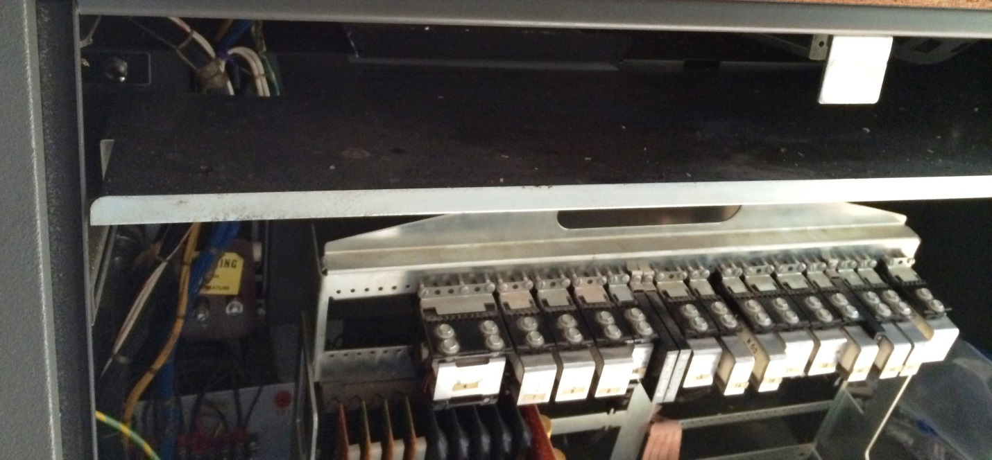

## Connecting the interface box to power

The new interface box will receive power from the line power at the power supply when the main switch of the keypunch is on. It should be built with two power leads having lug connectors. These are attached to the keypunch power supply terminal strip TB-1 at positions 1 and 3.

## Installing the DB-9 connector on the frame of the keypunch

The installer can drill an opening that will allow the DB-9 connector shell to poke out of the metal skin of the keypunch at whatever location suits the fancy of the installer. This opening should have two small openings drilled for the mounting bolt and nuts that hold the DB-9 connector in place, so that it can be un-mounted if the interface box is to be removed from the keypunch for any reason.

Another option is to have the cable enter the keypunch at the joint at the bottom left or right where the rear cover pivots – plenty of room for a cable to fit through there and be plugged into the new interface box. This is the preferred embodiment.

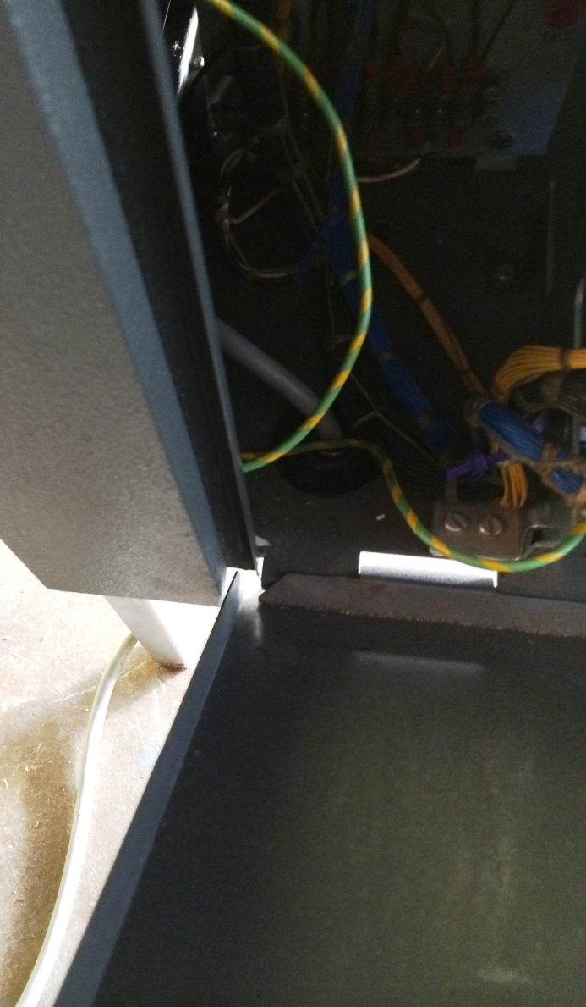

## Parts involved in the interface box

The processor is an Arduino Mega 2560 board – or compatible. I used a SainSmart version as it is cheaper and works just fine.

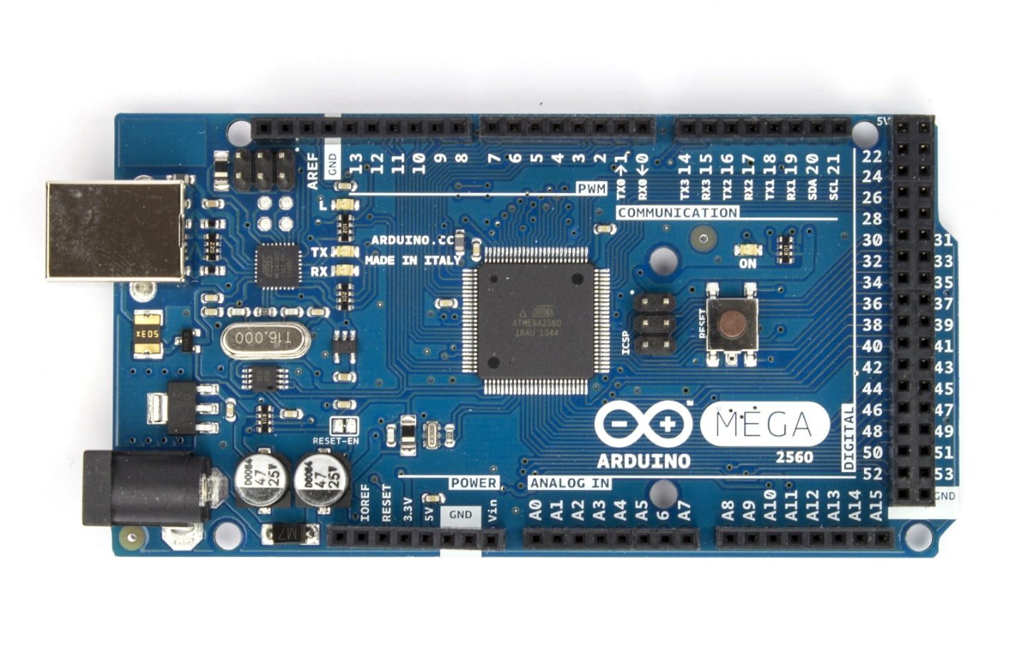

The interface needs to drive 16 relays that switch power to various solenoids in the keypunch. I selected a board that implemented 8 relays, photocoupler isolation of the inputs to minimize load on the Arduino and support for either normally open or normally closed behavior. The box held two of these boards.

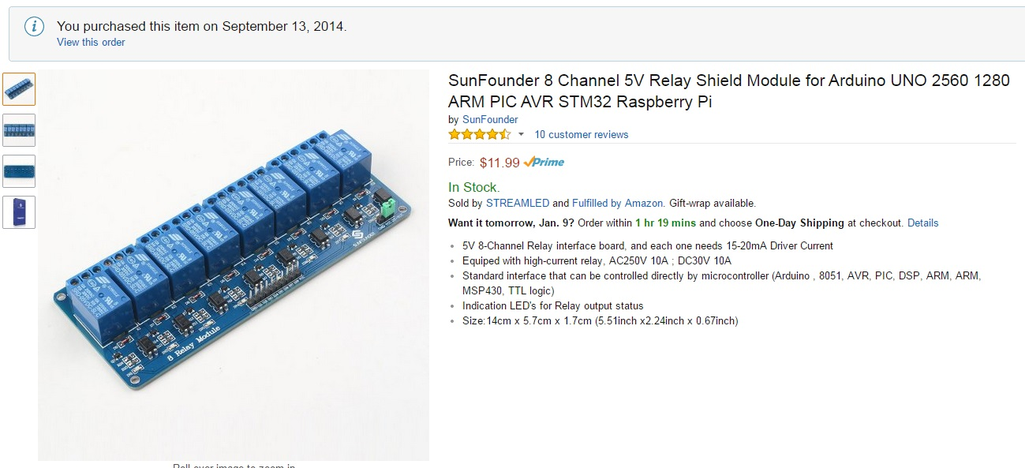

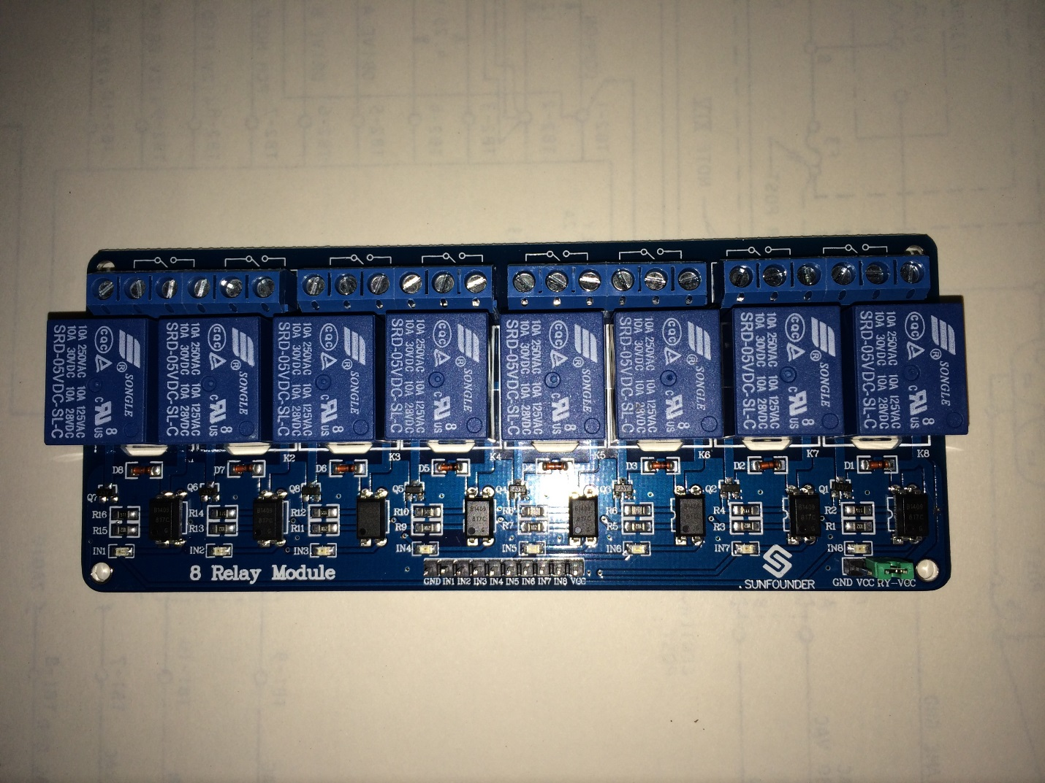

The serial port connection (DB9 connector) is supported by a voltage level translator to use the full RS232 voltage swings, while the Arduino is only driving with TTL levels (5V and 0V). I selected a suitable component that was ready to wire to the Arduino, with the connector already attached.

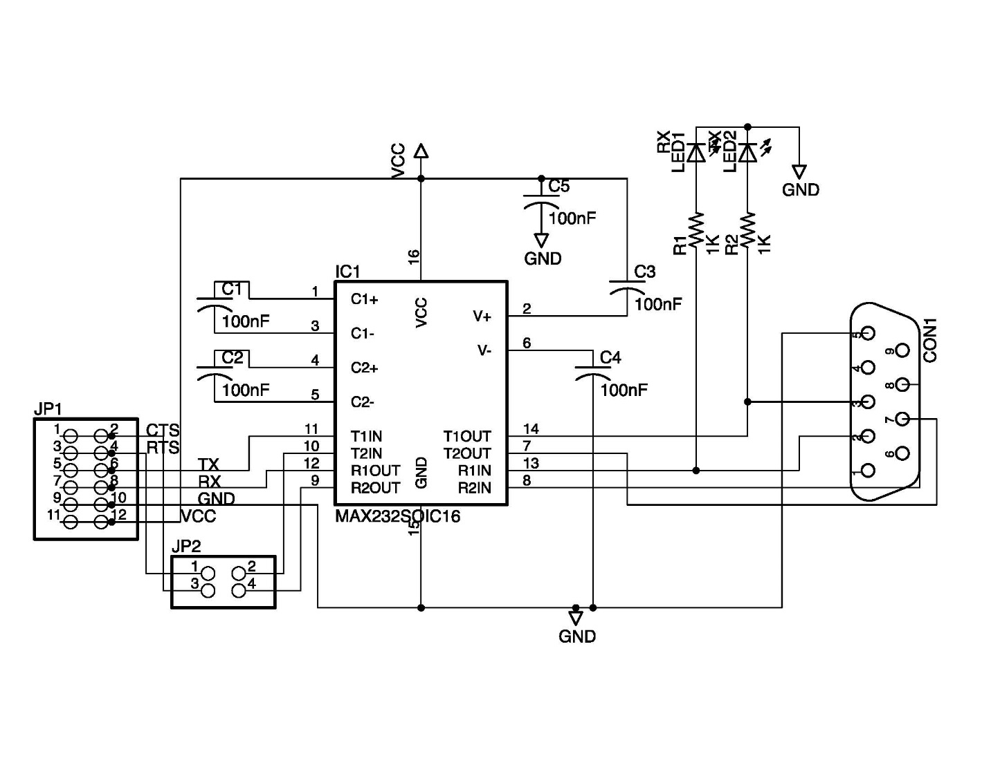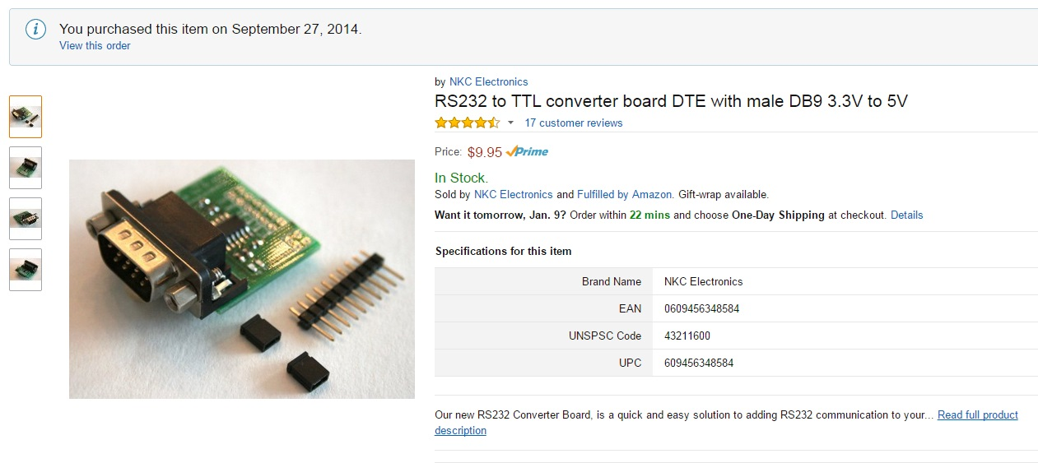

The voltage regulators on the Arduino board drop the 12V DC input down to the 5V used by the processor and intput/output pins. The demands of the relay boards can be larger than the capacity of the Arduino board, so I added a small board with a 5V regulator circuit to provide the power to the two relay boards.

I recommend a high capacity electrolytic capacitor be placed in the box to ensure that power doesn’t dip during use. I bought a power connector similar to the one on Arduinos, placed the new connector on the outside of the interface box and split the power in a Y. One branch went to a plug that would fit into the Arduino, the other branch went to the regulator board I built.

I used a 12V DC power brick with adequate current capacity, hooking its AC input wires to the keypunch AC power so that the main power switch of the keypunch turns on the interface box at the same time as the keypunch.

Find a suitable box to which you can mount two DB25 connectors, for the punch and read cables running to the keypunch circuits, a DB9 connector for the serial connection, and a power input jack to deliver 12V DC.

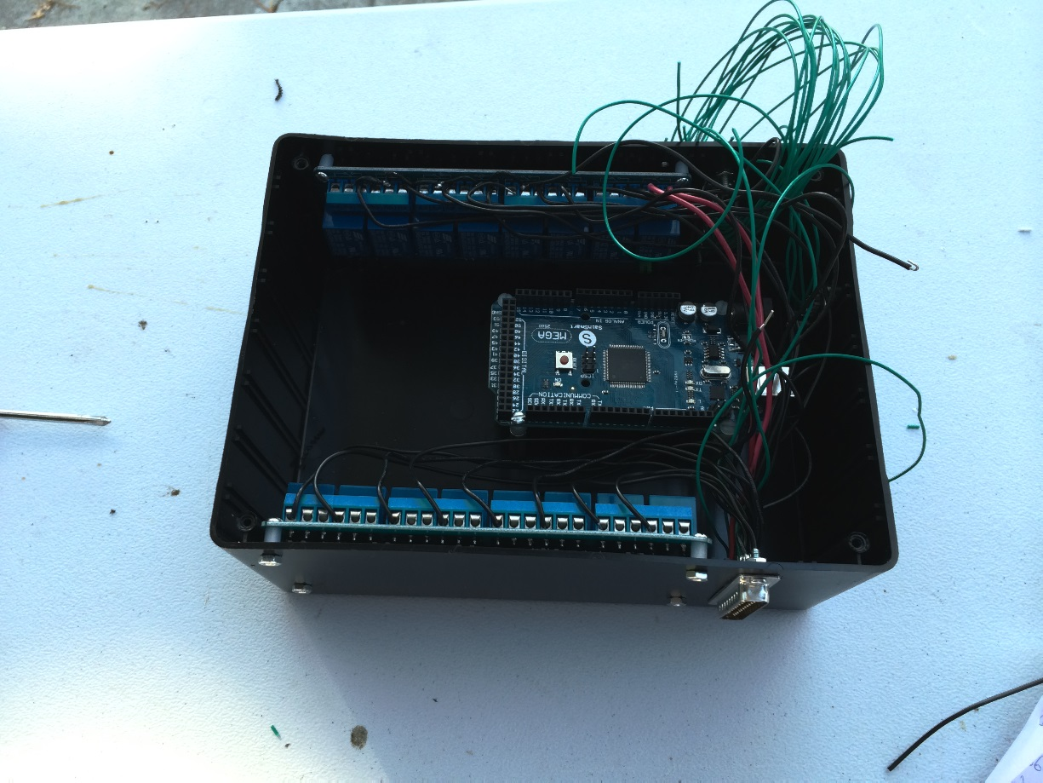

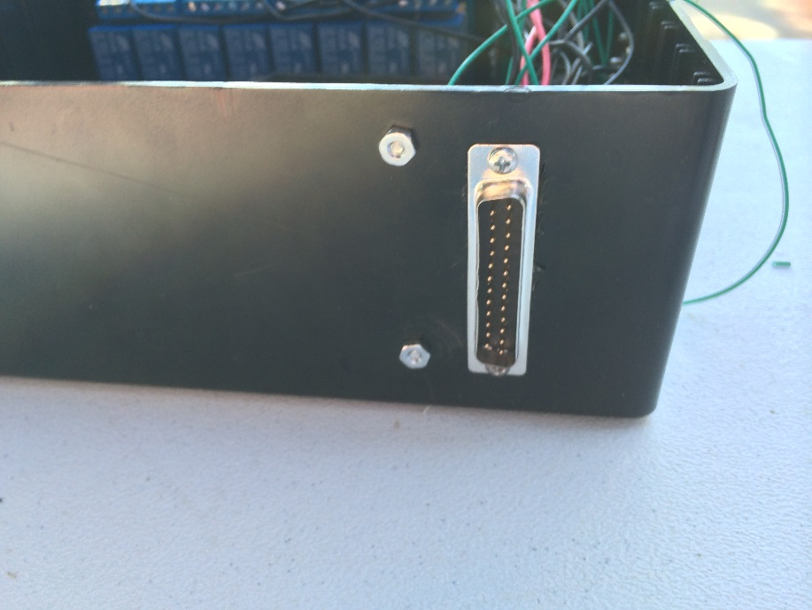

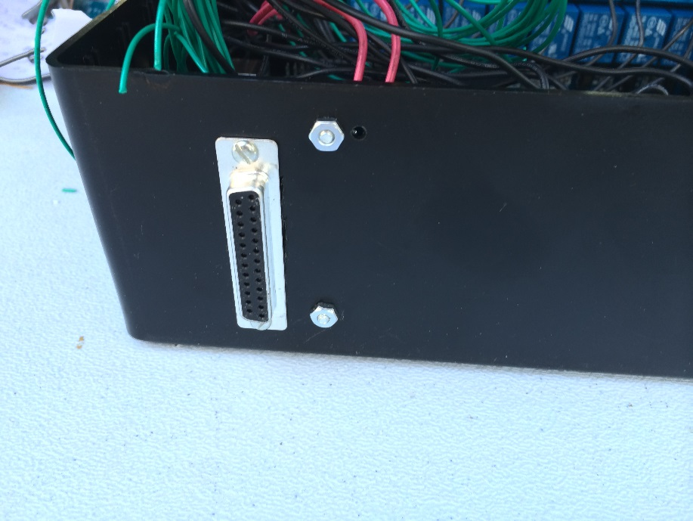

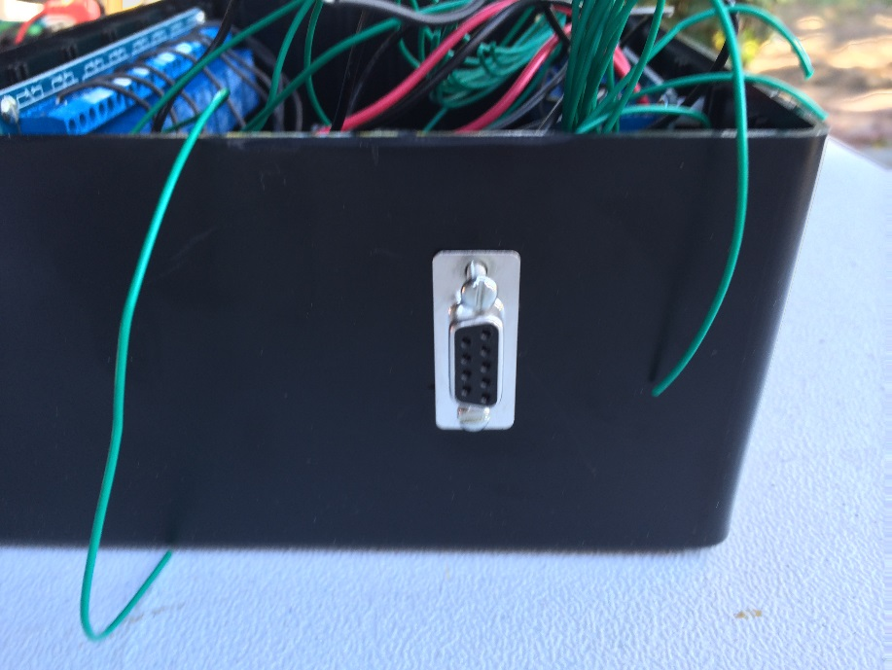

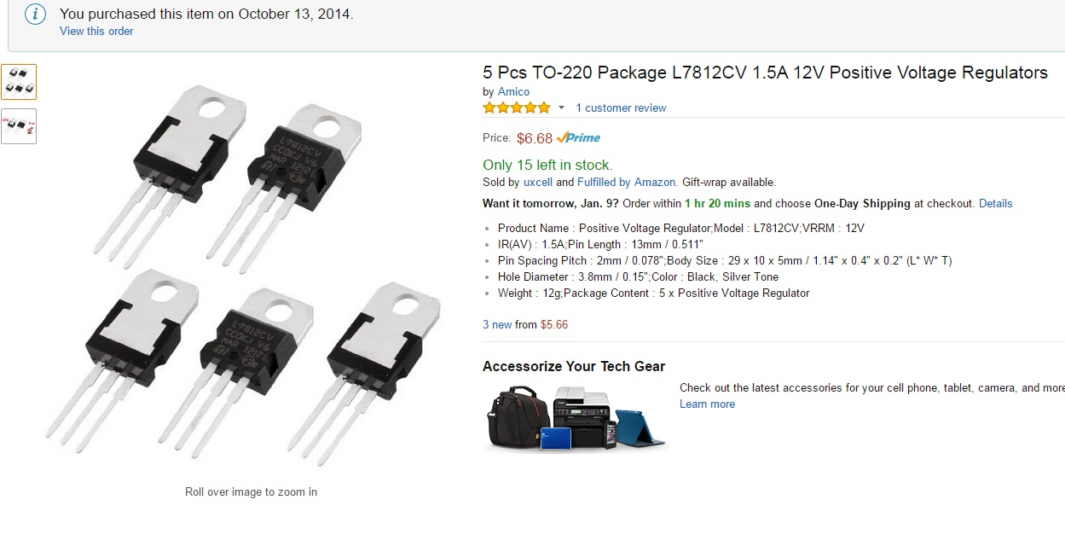

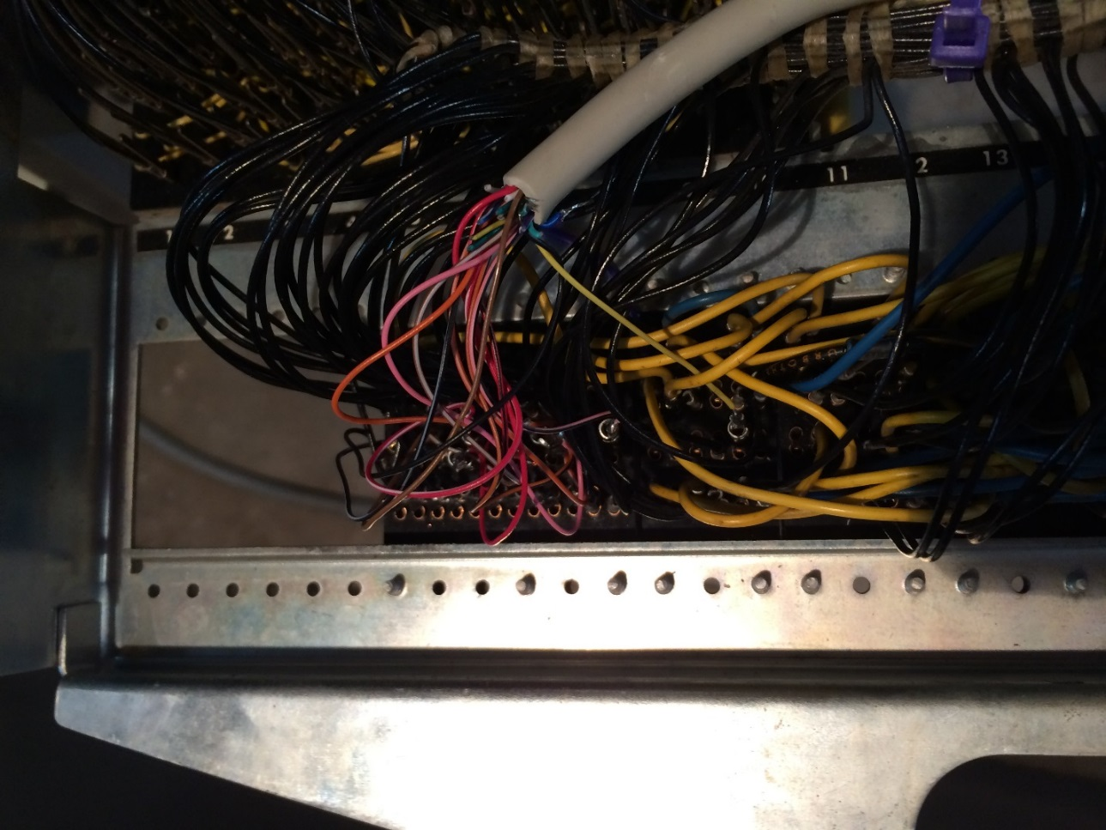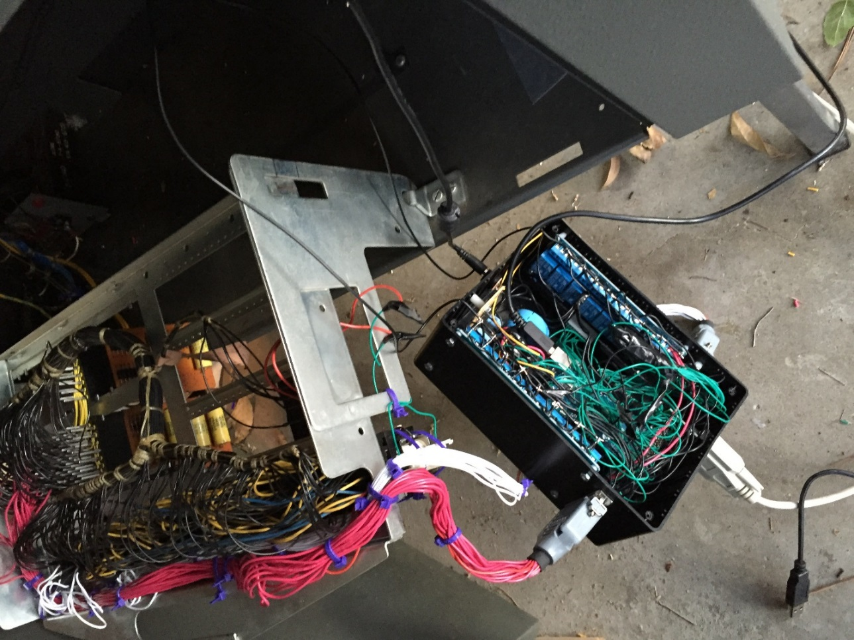

## Testing the new installation

Hook a serial terminal program to the DB-9 connector on the keypunch, using 9600 baud, DTE, 8 bit with no parity and 1 stop bit. When the keypunch is powered on, the interface will emit the ASCII string “Interface V2.0\n” if the interface box is working.

Type the following ascii characters to run a short installation diagnostic routine – “_Diag 0\n”_xx. This will test the default state of various circuits and report back with availability of the punch and reader cable. Note that the command must see the next delimiter (_) plus another character (since two _ in a row is an escape sequence).

Type the following ascii characters to run a quick check of the interface and keypunch together – “_Diag 1\n_xx”. Turn the autofeed switch off. When you see “Test begun\n” on the terminal, feed two cards.

When the second card is fed and the first has registered at the punch station, you will see the message “Card registered\n” and the program will punch rows 12 down to 9 in the first 12 columns of the card, then punch all 12 rows in a single column using multipunch, then release the card to move to the read station.

Hit the Reg key on the keypunch to register the second card in the punch station and the first card in the read station. The keypunch will space through 14 columns of the new card, while reading and verifying the contents of the first card via the read/sense station, then do a clear to move both cards up into the stacker.

The errors you may see during the step above are:

* First card did not verify for the punch in row x
* First card did not multipunch correctly
* Clear did not remove card from punch station
* Keypunch and interface operation is correct

This will conclude the Diag 1 test. The machine is now ready for use punching, reading or punching with verify.

Note 1 - Early models of 029 used reed relays mounted on a tray parallel to the ground while the wire relays in the newer models are installed on a plate perpendicular to the ground